**Evaluation – 2 – 07-09-2020 – Monday – CO3**

**Instructions**

1. **Look at the sample figure given to you, understand how it is plotted (which plot function, which data frame, what operations are applied on it before plotting, how are legends given etc) and generate this plot using your code (Matplotlib/Seaborn).**
2. **Your plot should have proper X label, Y label, plot title, markers, background, colors, gridlines, legends etc, even if it is not given in the sample figure given to you. The marks assigned to the question is for these too.**
3. **In a text box after your code for the question, type what you infer from your visualization of the question.**
4. Create different markers for different marital status and the marker size should proportional to age.

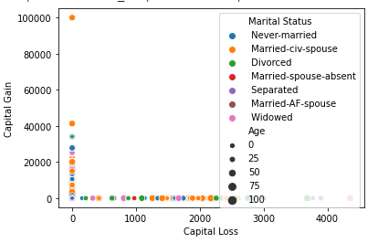

1. Make the line color green and marker triangle

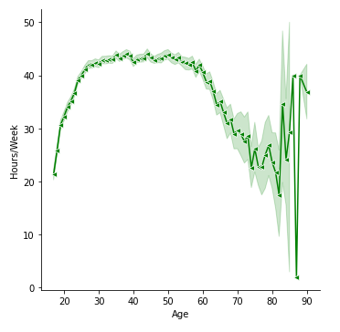

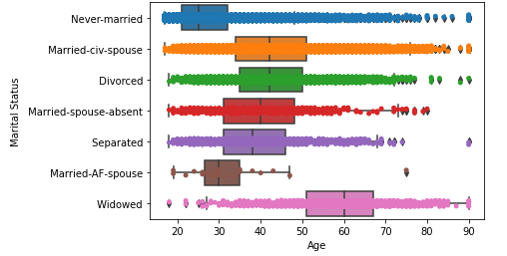

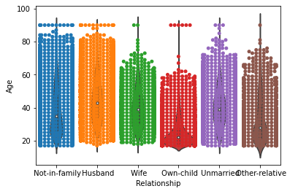

1. Legend at the outer of the plot to the centre

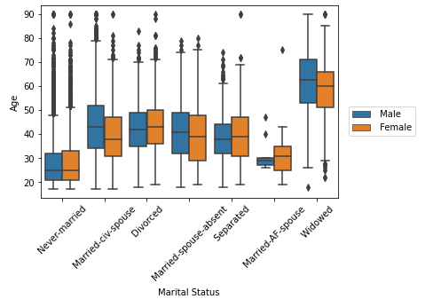

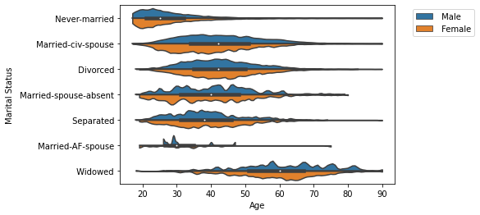

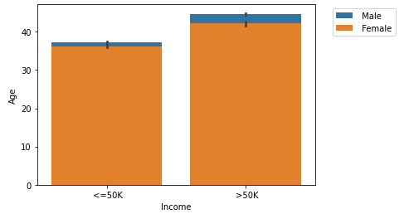

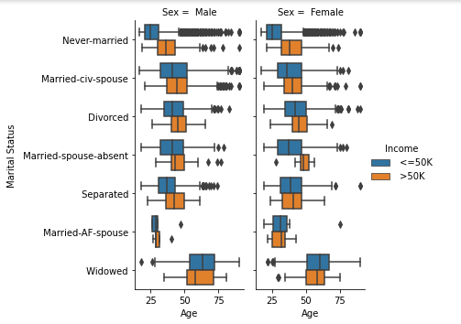

1. Shift the legend to a proper position outside the plot area

